Easily Interfaced to Microprocessors
- On-Chip Data Latches
- Monotonic Over the Entire A/D Conversion Range
- Segmented High-Order Bits Ensure Low-Glitch Output
- Interchangeable With Analog Devices AD7524, PMI PM-7524, and Micro Power Systems MP7524
- Fast Control Signaling for Digital
Signal-Processor Applications Including Interface With TMS320
- CMOS Technology
3 2 1 20 19

D, N, OR PW PACKAGE (TOP VIEW)

OUT1 | 1 | 16 | RFB
OUT2 | 2 | 15 | REF
GND | 3 | 14 | VDD
DB7 | 4 | 13 | WR
DB6 | 5 | 12 | CS
DB5 | 6 | 11 | DB0
DB4 | 7 | 10 | DB1
DB3 | 8 | 9 | DB2

FN PACKAGE (TOP VIEW)
OUT2 OUT1 NC RFB REF

KEY PERFORMANCE SPECIFICATIONS
Resolution | 8 Bits
Linearity error | 1/2LSB Max
Power dissipation at VDD = 5V Setting time | 5mW Max 100ns Max
Propagation delay time | 80ns Max

description
The TLC7524C, TLC7524E, and TLC7524I are
CMOS, 8-bit, digital-to-analog converters (DACs) designed for easy interface to most popular microprocessors.

NC−No internal connection
DB4 DB3 NC DB2 DB1
GND | 4 | 18 |  | VDD
DB7 | 5 | 17 |  | WR
NC | 6 | 16 |  | NC
DB6 | 7 | 15 |  | CS
DB5 | 8 | 14 |  | DB0
 | 9 10 1 | 1 12 13

The devices are 8-bit, multiplying DACs with input latches and load cycles similar to the write cycles of a random access memory. Segmenting the high-order bits minimizes glitches during changes in the most significant bits, which produce the highest glitch impulse. The devices provide accuracy to 1/2LSB without the need for thin-film resistors or laser trimming, while dissipating less than 5mW typically.
Featuring operation from a 5V to 15V single supply, these devices interface easily to most microprocessor buses or output ports. The 2- or 4-quadrant multiplying makes these devices an ideal choice for many microprocessor-controlled gain-setting and signal-control applications.
The TLC7524C is characterized for operation from 0°C to 70°C. The TLC7524I is characterized for operation from −25°C to +85°C. The TLC7524E is characterized for operation from − 40°C to +85°C.

Please be aware that an important notice concerning availability, standard warranty, and use in critical applications of Texas Instruments semiconductor products and disclaimers thereto appears at the end of this data sheet.
All trademarks are the property of their respective owners.

PRODUCTION DATA information is current as of publication date. Copyright © 1998−2007, Texas Instruments Incorporated
Products conform to specifications per the terms of Texas Instruments standard warranty. Production processing does not necessarily include testing of all parameters.

functional block diagram

15

R R R

REF

2R

S-1

2R

S-2

2R

S-3

2R 2R

S-8 R

16
RFB

- OUT1
- OUT2

12
CS
13
WR

Data Latches

- GND

4
DB7 (MSB)
5
DB6
6
DB5
11
DB0 (LSB)

Data Inputs
Terminal numbers shown are for the D or N package.

absolute maximum ratings over operating free-air temperature range (unless otherwise noted)

Supply voltage range, VDD
. . . . . . . . . . . . . . . . . . . . . . . . . . . . . . . . . . . . . . . . . . . . . . . . . . . . . . . −0.3V to 16.5V

Digital input voltage range, VI . . . . . . . . . . . . . . . . . . . . . . . . . . . . . . . . . . . . . . . . . . . . . . . . −0.3V to VDD + 0.3V

Reference voltage, Vref . . . . . . . . . . . . . . . . . . . . . . . . . . . . . . . . . . . . . . . . . . . . . . . . . . . . . . . . . . . . . . . . . . .
± 25V

Peak digital input current, II . . . . . . . . . . . . . . . . . . . . . . . . . . . . . . . . . . . . . . . . . . . . . . . . . . . . . . . . . . . . . . . . 10μA
Operating free-air temperature range, TA: TLC7524C . . . . . . . . . . . . . . . . . . . . . . . . . . . . . . . . . 0°C to +70°C
TLC7524I . . . . . . . . . . . . . . . . . . . . . . . . . . . . . . . −25°C to +85°C
TLC7524E . . . . . . . . . . . . . . . . . . . . . . . . . . . . . . −40°C to +85°C
Storage temperature range, Tstg . . . . . . . . . . . . . . . . . . . . . . . . . . . . . . . . . . . . . . . . . . . . . . . . . −65°C to +150°C

Case temperature for 10 seconds, TC: FN package . . . . . . . . . . . . . . . . . . . . . . . . . . . . . . . . . . . . . . . . .
+260°C

Lead temperature 1,6mm (1/16 inch) from case for 10 seconds: D, N, or PW package

package/ordering information
. . . . . . . . . . .
+260°C

For the most current package and ordering information, see the Package Option Addendum at the end of this document, or see the TI website at www.ti.com.

recommended operating conditions

 |  | VDD = 5V | VDD = 15V | UNIT
 |  | MIN NOM MAX | MIN NOM MAX
Supply voltage, VDD |  | 4.75 5 5.25 | 14.5 15 15.5 | V
Reference voltage, Vref |  | ± 10 | ± 10 | V
High-level input voltage, VIH |  | 2.4 | 13.5 | V
Low-level input voltage, VIL |  | 0.8 | 1.5 | V
CS setup time, tsu(CS) |  | 40 | 40 | ns
CS hold time, th(CS) |  | 0 | 0 | ns
Data bus input setup time, tsu(D) |  | 25 | 25 | ns
Data bus input hold time, th(D) |  | 10 | 10 | ns
Pulse duration, WR low, tw(WR) |  | 40 | 40 | ns
Operating free-air temperature, TA | TLC7524C | 0 +70 | 0 +70 | °C
 | TLC7524I | −25 +85 | −25 +85
 | TLC7524E | −40 +85 | −40 +85

electrical characteristics over recommended operating free-air temperature range, Vref = ±10V, OUT1 and OUT2 at GND (unless otherwise noted)

PARAMETER |  | TEST CONDITIONS | VDD = 5V | VDD = 15V | UNIT
 |  |  | MIN TYP MAX | MIN TYP MAX
IIH High-level input current |  | VI = VDD | 10 | 10 | μA
IIL Low-level input current |  | VI = 0 | −10 | −10 | μA
IIkg Output leakage current | OUT1 | DB0−DB7 at 0V, WR, CS at 0V,  Vref = ± 10V | ± 400 | ± 200 | nA
 | OUT2 | DB0−DB7 at VDD, WR, CS at 0V,  Vref = ± 10V | ± 400 | ± 200
IDD Supply current | Quiescent | DB0−DB7 at VIHmin or VILmax | 1 | 2 | mA
 | Standby | DB0−DB7 at 0V or VDD | 500 | 500 | μA
kSVS Supply voltage sensitivity,  Δgain/ΔVDD |  | ΔVDD = ± 10% | 0.01 0.16 | 0.005 0.04 | %FSR/%
Ci Input capacitance, DB0−DB7, WR, CS |  | VI = 0 | 5 | 5 | pF
Co Output capacitance | OUT1 | DB0−DB7 at 0V, WR, CS at 0V | 30 | 30 | pF
 | OUT2 |  | 120 | 120
 | OUT1 | DB0−DB7 at VDD, WR, CS at 0V | 120 | 120
 | OUT2 |  | 30 | 30
Reference input impedance (REF to GND) |  |  | 5 20 | 5 20 | kΩ

operating characteristics over recommended operating free-air temperature range, Vref = ±10V, OUT1 and OUT2 at GND (unless otherwise noted)

PARAMETER | TEST CONDITIONS | VDD = 5V | VDD = 15V | UNIT
 |  | MIN TYP MAX | MIN TYP MAX
Linearity error |  | ± 0.5 | ± 0.5 | LSB
Gain error | See Note 1 | ± 2.5 | ± 2.5 | LSB
Settling time (to 1/2 LSB) | See Note 2 | 100 | 100 | ns
Propagation delay from digital input to 90% of final analog output current | See Note 2 | 80 | 80 | ns
Feedthrough at OUT1 or OUT2 | Vref = ±10V (100kHz sinewave) WR and CS at 0V, DB0−DB7 at 0V | 0.5 | 0.5 | %FSR
Temperature coefficient of gain | TA = +25°C to MAX | ± 0.004 | ± 0.001 | %FSR/°C
NOTES: 1. Gain error is measured using the internal feedback resistor. Nominal full-scale range (FSR) = Vref − 1LSB.
2. OUT1 load = 100Ω, Cext = 13pF, WR at 0V, CS at 0V, DB0 − DB7 at 0V to VDD or VDD to 0V.

operating sequence

tsu(CS)
CS

th(CS)

tw(WR)

WR

tsu(D)

th(D)

DB0−DB7

voltage-mode operation

It is possible to operate the current-multiplying DAC in these devices in a voltage mode. In the voltage mode, a fixed voltage is placed on the current output terminal. The analog output voltage is then available at the reference voltage terminal. Figure 1 is an example of a current-multiplying DAC, which is operated in voltage mode.
R R R
2R
2R
2R
2R
0
1
R
REF (Analog Output Voltage)

OUT1 (Fixed Input Voltage) OUT2

Figure 1. Voltage Mode Operation

The relationship between the fixed-input voltage and the analog-output voltage is given by the following equation:

where
VO = VI (D/256)

VO = analog output voltage VI = fixed input voltage
D = digital input code converted to decimal

In voltage-mode operation, these devices meet the following specification:

PARAMETER | TEST CONDITIONS |  |  |  | MIN MAX | UNIT
Linearity error at REF | VDD = 5V, | OUT1 = 2.5V, | OUT2 at GND, | TA = +25°C | 1 | LSB

The TLC7524C, TLC7524E, and TLC7524I are 8-bit multiplying DACs consisting of an inverted R-2R ladder, analog switches, and data input latches. Binary-weighted currents are switched between the OUT1 and OUT2 bus lines, thus maintaining a constant current in each ladder leg independent of the switch state. The high-order bits are decoded. These decoded bits, through a modification in the R-2R ladder, control three equally-weighted current sources. Most applications only require the addition of an external operational amplifier and a voltage reference.
The equivalent circuit for all digital inputs low is seen in Figure 2. With all digital inputs low, the entire reference current, Iref, is switched to OUT2. The current source I/256 represents the constant current flowing through the termination resistor of the R-2R ladder, while the current source IIkg represents leakage currents to the substrate. The capacitances appearing at OUT1 and OUT2 are dependent upon the digital input code. With all digital inputs high, the off-state switch capacitance (30pF maximum) appears at OUT2 and the on-state switch capacitance (120pF maximum) appears at OUT1. With all digital inputs low, the situation is reversed as shown in Figure 2. Analysis of the circuit for all digital inputs high is similar to Figure 2; however, in this case, Iref would be switched to OUT1.
The DAC on these devices interfaces to a microprocessor through the data bus and the CS and WR control signals. When CS and WR are both low, analog output on these devices responds to the data activity on the DB0−DB7 data bus inputs. In this mode, the input latches are transparent and input data directly affects the analog output. When either the CS signal or WR signal goes high, the data on the DB0−DB7 inputs are latched until the CS and WR signals go low again. When CS is high, the data inputs are disabled regardless of the state of the WR signal.
These devices are capable of performing 2-quadrant or full 4-quadrant multiplication. Circuit configurations for 2-quadrant or 4-quadrant multiplication are shown in Figure 3 and Figure 4. Table 1 and Table 2 summarize input coding for unipolar and bipolar operation respectively.

RFB
R
30 pF

IIkg
OUT1

Iref
REF OUT2
I/256
IIkg
120 pF

Figure 2. TLC7524 Equivalent Circuit With All Digital Inputs Low

Vref VDD
RA = 2 kΩ (see Note A)
RB
RFB
C (see Note B)
OUT1
−
OUT2
+
GND

DB0−DB7

CS WR

Output

NOTES: A. RA and RB used only if gain adjustment is required.
B. C phase compensation (10-15 pF) is required when using high-speed amplifiers to prevent
ringing or oscillation.

Figure 3. Unipolar Operation (2-Quadrant Multiplication)

RA = 2 kΩ (see Note A)

DB0−DB7

CS WR
Vref
VDD

GND

RB

RFB
OUT1 OUT2

C (see Note B)

−

+

20 kΩ

10 kΩ

20 kΩ

−

+

5 kΩ

Output

NOTES: A. RA and RB used only if gain adjustment is required.
B. C phase compensation (10-15 pF) is required when using high-speed amplifiers to prevent ringing or oscillation.

Figure 4. Bipolar Operation (4-Quadrant Operation)

Table 1. Unipolar Binary Code Table 2. Bipolar (Offset Binary) Code
DIGITAL INPUT  (see Note 3) | ANALOG OUTPUT
MSB LSB
1 1 1 1 1 1 1 1 | − Vref (255/256)
1 0 0 0 0 0 0 1 | − Vref (129/256)
1 0 0 0 0 0 0 0 | − Vref (128/256) = −Vref/2
0 1 1 1 1 1 1 1 | − Vref (127/256)
0 0 0 0 0 0 0 1 | − Vref (1/256)
0 0 0 0 0 0 0 0 | 0

DIGITAL INPUT  (see Note 4) | ANALOG OUTPUT
MSB LSB
1 1 1 1 1 1 1 1 | Vref (127/128)
1 0 0 0 0 0 0 1 | Vref (1/128)
1 0 0 0 0 0 0 0 | 0
0 1 1 1 1 1 1 1 | − Vref (1/128)
0 0 0 0 0 0 0 1 | − Vref (127/128)
0 0 0 0 0 0 0 0 | − Vref

NOTE 3: LSB = 1/256 (Vref) NOTE 4: LSB = 1/128 (Vref)

microprocessor interfaces

D0−D7
Z−80A
WR
IORQ
A0−A15
Decode Logic
Data Bus
WR
DB0−DB7
TLC7524
CS
OUT1

OUT2
Address Bus

Figure 5. TLC7524: Z-80A Interface
D0−D7 6800
φ2
VMA
A0−A15

Decode Logic
Data Bus

WR
DB0−DB7
TLC7524
CS
OUT1

OUT2
Address Bus
Figure 6. TLC7524: 6800 Interface

PRINCIPLES OF OPERATION

microprocessor interfaces (continued)

Decode Logic
A8−A15
8051
ALE
WR
AD0−AD7

8-Bit Latch
Address Bus
CS
OUT1
WR TLC7524
OUT2
DB0−DB7
Adress/Data Bus

Figure 7. TLC7524: 8051 Interface

Revision History

DATE | REV | PAGE | SECTION | DESCRIPTION
6/07 | D | Front Page | — | Deleted Available Options table.
 |  | 2 | — | Inserted Package/Ordering information.
NOTE: Page numbers for previous revisions may differ from page numbers in the current version.


PACKAGE OPTION ADDENDUM

www.ti.com 11-Nov-2025

PACKAGING INFORMATION

Orderable part number | Status Material type  (1) (2) |  | Package | Pins | Package qty | Carrier | RoHS  (3) | Lead finish/ Ball material  (4) | MSL rating/ Peak reflow  (5) | Op temp (°C) | Part marking  (6)
TLC7524CD | Active | Production | SOIC (D) | 16 | 40 | TUBE | Yes | NIPDAU | Level-1-260C-UNLIM | 0 to 70 | TLC7524C
TLC7524CD.A | Active | Production | SOIC (D) | 16 | 40 | TUBE | Yes | NIPDAU | Level-1-260C-UNLIM | 0 to 70 | TLC7524C
TLC7524CDG4 | Active | Production | SOIC (D) | 16 | 40 | TUBE | Yes | NIPDAU | Level-1-260C-UNLIM | 0 to 70 | TLC7524C
TLC7524CDR | Active | Production | SOIC (D) | 16 | 2500 | LARGE T&R | Yes | NIPDAU | Level-1-260C-UNLIM | 0 to 70 | TLC7524C
TLC7524CDR.A | Active | Production | SOIC (D) | 16 | 2500 | LARGE T&R | Yes | NIPDAU | Level-1-260C-UNLIM | 0 to 70 | TLC7524C
TLC7524CFNR | Obsolete | Production | PLCC (FN) | 20 | - | - | Call TI | Call TI | 0 to 70 | TLC7524C
TLC7524CN | Active | Production | PDIP (N) | 16 | 25 | TUBE | Yes | NIPDAU | N/A for Pkg Type | 0 to 70 | TLC7524CN
TLC7524CN.A | Active | Production | PDIP (N) | 16 | 25 | TUBE | Yes | NIPDAU | N/A for Pkg Type | 0 to 70 | TLC7524CN
TLC7524CNE4 | Active | Production | PDIP (N) | 16 | 25 | TUBE | Yes | NIPDAU | N/A for Pkg Type | 0 to 70 | TLC7524CN
TLC7524CNS | Active | Production | SOP (NS) | 16 | 50 | TUBE | Yes | NIPDAU | Level-1-260C-UNLIM | 0 to 70 | TLC7524
TLC7524CNS.A | Active | Production | SOP (NS) | 16 | 50 | TUBE | Yes | NIPDAU | Level-1-260C-UNLIM | 0 to 70 | TLC7524
TLC7524CNSR | Active | Production | SOP (NS) | 16 | 2000 | LARGE T&R | Yes | NIPDAU | Level-1-260C-UNLIM | 0 to 70 | TLC7524
TLC7524CNSR.A | Active | Production | SOP (NS) | 16 | 2000 | LARGE T&R | Yes | NIPDAU | Level-1-260C-UNLIM | 0 to 70 | TLC7524
TLC7524CPW | Active | Production | TSSOP (PW) | 16 | 90 | TUBE | Yes | NIPDAU | Level-1-260C-UNLIM | 0 to 70 | P7524
TLC7524CPW.A | Active | Production | TSSOP (PW) | 16 | 90 | TUBE | Yes | NIPDAU | Level-1-260C-UNLIM | 0 to 70 | P7524
TLC7524CPWR | Active | Production | TSSOP (PW) | 16 | 2000 | LARGE T&R | Yes | NIPDAU | Level-1-260C-UNLIM | 0 to 70 | P7524
TLC7524CPWR.A | Active | Production | TSSOP (PW) | 16 | 2000 | LARGE T&R | Yes | NIPDAU | Level-1-260C-UNLIM | 0 to 70 | P7524
TLC7524ED | Active | Production | SOIC (D) | 16 | 40 | TUBE | Yes | NIPDAU | Level-1-260C-UNLIM | -40 to 85 | TLC7524E
TLC7524ED.A | Active | Production | SOIC (D) | 16 | 40 | TUBE | Yes | NIPDAU | Level-1-260C-UNLIM | -40 to 85 | TLC7524E
TLC7524EDR | Active | Production | SOIC (D) | 16 | 2500 | LARGE T&R | Yes | NIPDAU | Level-1-260C-UNLIM | -40 to 85 | TLC7524E
TLC7524EDR.A | Active | Production | SOIC (D) | 16 | 2500 | LARGE T&R | Yes | NIPDAU | Level-1-260C-UNLIM | -40 to 85 | TLC7524E
TLC7524EN | Active | Production | PDIP (N) | 16 | 25 | TUBE | Yes | NIPDAU | N/A for Pkg Type | -40 to 85 | TLC7524EN
TLC7524EN.A | Active | Production | PDIP (N) | 16 | 25 | TUBE | Yes | NIPDAU | N/A for Pkg Type | -40 to 85 | TLC7524EN
TLC7524ID | Active | Production | SOIC (D) | 16 | 40 | TUBE | Yes | NIPDAU | Level-1-260C-UNLIM | -25 to 85 | TLC7524I
TLC7524ID.A | Active | Production | SOIC (D) | 16 | 40 | TUBE | Yes | NIPDAU | Level-1-260C-UNLIM | -25 to 85 | TLC7524I
TLC7524IDR | Active | Production | SOIC (D) | 16 | 2500 | LARGE T&R | Yes | NIPDAU | Level-1-260C-UNLIM | -25 to 85 | TLC7524I
TLC7524IDR.A | Active | Production | SOIC (D) | 16 | 2500 | LARGE T&R | Yes | NIPDAU | Level-1-260C-UNLIM | -25 to 85 | TLC7524I
TLC7524IFN | Obsolete | Production | PLCC (FN) | 20 | - | - | Call TI | Call TI | -25 to 85 | TLC7524I
TLC7524IN | Active | Production | PDIP (N) | 16 | 25 | TUBE | Yes | NIPDAU | N/A for Pkg Type | -25 to 85 | TLC7524IN

Addendum-Page 1


PACKAGE OPTION ADDENDUM

www.ti.com 11-Nov-2025

Orderable part number | Status  (1) | Material type  (2) | Package | Pins | Package qty | Carrier | RoHS  (3) | Lead finish/ Ball material  (4) | MSL rating/ Peak reflow  (5) | Op temp (°C) | Part marking  (6)
TLC7524IN.A | Active | Production | PDIP (N) | 16 | 25 | TUBE | Yes | NIPDAU | N/A for Pkg Type | -25 to 85 | TLC7524IN
TLC7524IPW | Active | Production | TSSOP (PW) | 16 | 90 | TUBE | Yes | NIPDAU | Level-1-260C-UNLIM | -25 to 85 | Y7524
TLC7524IPW.A | Active | Production | TSSOP (PW) | 16 | 90 | TUBE | Yes | NIPDAU | Level-1-260C-UNLIM | -25 to 85 | Y7524
TLC7524IPWR | Active | Production | TSSOP (PW) | 16 | 2000 | LARGE T&R | Yes | NIPDAU | Level-1-260C-UNLIM | -25 to 85 | Y7524
TLC7524IPWR.A | Active | Production | TSSOP (PW) | 16 | 2000 | LARGE T&R | Yes | NIPDAU | Level-1-260C-UNLIM | -25 to 85 | Y7524

(1) Status: For more details on status, see our product life cycle.

(2) Material type: When designated, preproduction parts are prototypes/experimental devices, and are not yet approved or released for full production. Testing and final process, including without limitation quality assurance, reliability performance testing, and/or process qualification, may not yet be complete, and this item is subject to further changes or possible discontinuation. If available for ordering, purchases will be subject to an additional waiver at checkout, and are intended for early internal evaluation purposes only. These items are sold without warranties of any kind.

(3) RoHS values: Yes, No, RoHS Exempt. See the TI RoHS Statement for additional information and value definition.

(4) Lead finish/Ball material: Parts may have multiple material finish options. Finish options are separated by a vertical ruled line. Lead finish/Ball material values may wrap to two lines if the finish value exceeds the maximum column width.

(5) MSL rating/Peak reflow: The moisture sensitivity level ratings and peak solder (reflow) temperatures. In the event that a part has multiple moisture sensitivity ratings, only the lowest level per JEDEC standards is shown. Refer to the shipping label for the actual reflow temperature that will be used to mount the part to the printed circuit board.

(6) Part marking: There may be an additional marking, which relates to the logo, the lot trace code information, or the environmental category of the part.

Multiple part markings will be inside parentheses. Only one part marking contained in parentheses and separated by a "~" will appear on a part. If a line is indented then it is a continuation of the previous line and the two combined represent the entire part marking for that device.

Important Information and Disclaimer:The information provided on this page represents TI's knowledge and belief as of the date that it is provided. TI bases its knowledge and belief on information provided by third parties, and makes no representation or warranty as to the accuracy of such information. Efforts are underway to better integrate information from third parties. TI has taken and continues to take reasonable steps to provide representative and accurate information but may not have conducted destructive testing or chemical analysis on incoming materials and chemicals. TI and TI suppliers consider certain information to be proprietary, and thus CAS numbers and other limited information may not be available for release.

In no event shall TI's liability arising out of such information exceed the total purchase price of the TI part(s) at issue in this document sold by TI to Customer on an annual basis.

Addendum-Page 2

www.ti.com 24-Jul-2025

TAPE AND REEL INFORMATION

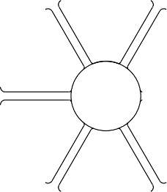REEL DIMENSIONS TAPE DIMENSIONS

Reel Diameter
K0 P1
B0
W
Cavity
A0

A0 | Dimension designed to accommodate the component width
B0 | Dimension designed to accommodate the component length
K0 | Dimension designed to accommodate the component thickness
W | Overall width of the carrier tape
P1 | Pitch between successive cavity centers

Reel Width (W1)
QUADRANT ASSIGNMENTS FOR PIN 1 ORIENTATION IN TAPE
Sprocket Holes
Q1
Q2
Q3
Q4
Q1 | Q2
Q3 | Q4

User Direction of Feed

Pocket Quadrants

*All dimensions are nominal
Device | Package Type | Package Drawing | Pins | SPQ | Reel Diameter (mm) | Reel Width W1 (mm) | A0  (mm) | B0  (mm) | K0  (mm) | P1  (mm) | W  (mm) | Pin1 Quadrant
TLC7524CDR | SOIC | D | 16 | 2500 | 330.0 | 16.4 | 6.5 | 10.3 | 2.1 | 8.0 | 16.0 | Q1
TLC7524CNSR | SOP | NS | 16 | 2000 | 330.0 | 16.4 | 8.1 | 10.4 | 2.5 | 12.0 | 16.0 | Q1
TLC7524CPWR | TSSOP | PW | 16 | 2000 | 330.0 | 12.4 | 6.9 | 5.6 | 1.6 | 8.0 | 12.0 | Q1
TLC7524EDR | SOIC | D | 16 | 2500 | 330.0 | 16.4 | 6.5 | 10.3 | 2.1 | 8.0 | 16.0 | Q1
TLC7524IDR | SOIC | D | 16 | 2500 | 330.0 | 16.4 | 6.5 | 10.3 | 2.1 | 8.0 | 16.0 | Q1
TLC7524IPWR | TSSOP | PW | 16 | 2000 | 330.0 | 12.4 | 6.9 | 5.6 | 1.6 | 8.0 | 12.0 | Q1


PACKAGE MATERIALS INFORMATION

www.ti.com 24-Jul-2025

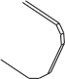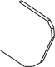*All dimensions are nominal
TAPE AND REEL BOX DIMENSIONS
Width (mm)
Device | Package Type | Package Drawing | Pins | SPQ | Length (mm) | Width (mm) | Height (mm)
TLC7524CDR | SOIC | D | 16 | 2500 | 350.0 | 350.0 | 43.0
TLC7524CNSR | SOP | NS | 16 | 2000 | 353.0 | 353.0 | 32.0
TLC7524CPWR | TSSOP | PW | 16 | 2000 | 353.0 | 353.0 | 32.0
TLC7524EDR | SOIC | D | 16 | 2500 | 350.0 | 350.0 | 43.0
TLC7524IDR | SOIC | D | 16 | 2500 | 350.0 | 350.0 | 43.0
TLC7524IPWR | TSSOP | PW | 16 | 2000 | 353.0 | 353.0 | 32.0

Pack Materials-Page 2

www.ti.com 24-Jul-2025

TUBE

T - Tube
height L - Tube length

W - Tube width

B - Alignment groove width

*All dimensions are nominal
Device | Package Name | Package Type | Pins | SPQ | L (mm) | W (mm) | T (µm) | B (mm)
TLC7524CD | D | SOIC | 16 | 40 | 505.46 | 6.76 | 3810 | 4
TLC7524CD.A | D | SOIC | 16 | 40 | 505.46 | 6.76 | 3810 | 4
TLC7524CDG4 | D | SOIC | 16 | 40 | 505.46 | 6.76 | 3810 | 4
TLC7524CN | N | PDIP | 16 | 25 | 506 | 13.97 | 11230 | 4.32
TLC7524CN.A | N | PDIP | 16 | 25 | 506 | 13.97 | 11230 | 4.32
TLC7524CNE4 | N | PDIP | 16 | 25 | 506 | 13.97 | 11230 | 4.32
TLC7524CNS | NS | SOP | 16 | 50 | 530 | 10.5 | 4000 | 4.1
TLC7524CNS.A | NS | SOP | 16 | 50 | 530 | 10.5 | 4000 | 4.1
TLC7524CPW | PW | TSSOP | 16 | 90 | 530 | 10.2 | 3600 | 3.5
TLC7524CPW.A | PW | TSSOP | 16 | 90 | 530 | 10.2 | 3600 | 3.5
TLC7524ED | D | SOIC | 16 | 40 | 505.46 | 6.76 | 3810 | 4
TLC7524ED.A | D | SOIC | 16 | 40 | 505.46 | 6.76 | 3810 | 4
TLC7524EN | N | PDIP | 16 | 25 | 506 | 13.97 | 11230 | 4.32
TLC7524EN.A | N | PDIP | 16 | 25 | 506 | 13.97 | 11230 | 4.32
TLC7524ID | D | SOIC | 16 | 40 | 505.46 | 6.76 | 3810 | 4
TLC7524ID.A | D | SOIC | 16 | 40 | 505.46 | 6.76 | 3810 | 4
TLC7524IN | N | PDIP | 16 | 25 | 506 | 13.97 | 11230 | 4.32
TLC7524IN.A | N | PDIP | 16 | 25 | 506 | 13.97 | 11230 | 4.32
TLC7524IPW | PW | TSSOP | 16 | 90 | 530 | 10.2 | 3600 | 3.5
TLC7524IPW.A | PW | TSSOP | 16 | 90 | 530 | 10.2 | 3600 | 3.5


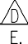
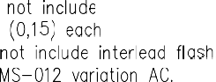


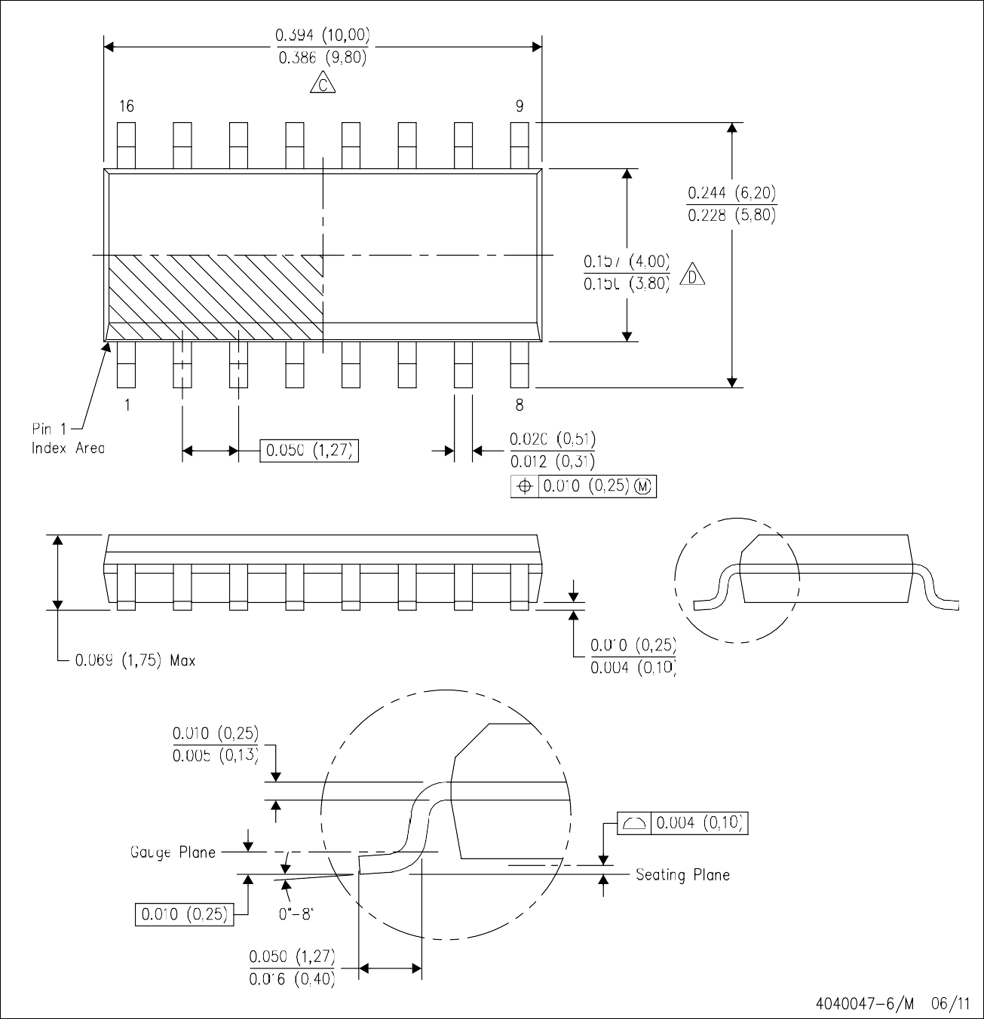



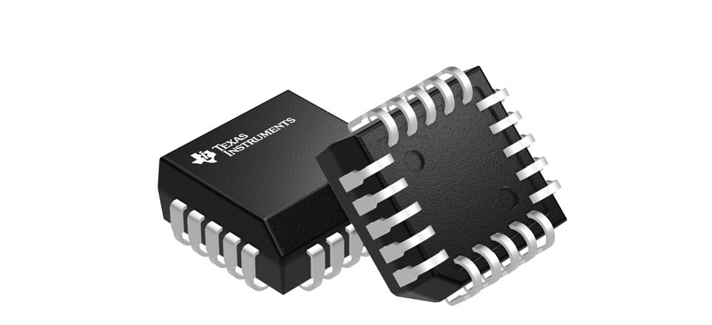

FN0020A
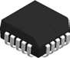 PACKAGE OUTLINE

PLCC - 4.57 mm max height

SCALE 1.300

PLASTIC CHIP CARRIER

B .350-.356
[8.89-9.04]
NOTE 3
A 3 1 20

.180 MAX
[4.57]

(.008)
[0.2]

.020 MIN
[0.51]

4 18

.350-.356
[8.89-9.04]
NOTE 3
PIN 1 ID (OPTIONAL)

.283-.339
[7.19-8.61]

8 14

20X .026-.032
[0.66-0.81]
9 13

.090-.120
[2.29-3.04]

TYP

C

20X .013-.021
[0.33-0.53]

16X
 | .007 [0.18] | C | A | B

SEATING PLANE

.004 [0.1] C
.050
[1.27]

.385-.395
[9.78-10.03] TYP

4215152/B 04/2017
NOTES:

- All linear dimensions are in inches. Any dimensions in brackets are in millimeters. Any dimensions in parenthesis are for reference only. Controlling dimensions are in inches. Dimensioning and tolerancing per ASME Y14.5M.
- This drawing is subject to change without notice.
- Dimension does not include mold protrusion. Maximum allowable mold protrusion .01 in [0.25 mm] per side.
- Reference JEDEC registration MS-018.

FN0020A

EXAMPLE BOARD LAYOUT

PLCC - 4.57 mm max height
PLASTIC CHIP CARRIER

20X (.096 )
[2.45]

3
SYMM

1 20

(R.002 ) TYP [0.05]

20X (.025 )
[0.64] 4
18

SYMM

(.327)
[8.3]

16X (.050 )

[1.27] 14
8

9 13
(.327)
[8.3]

LAND PATTERN EXAMPLE
EXPOSED METAL SHOWN SCALE:6X

.002 MAX
[0.05]
EXPOSED METAL
.002 MIN
[0.05]
EXPOSED METAL

ALL AROUND
ALL AROUND

METAL SOLDER MASK OPENING
NON SOLDER MASK DEFINED (PREFERRED)
SOLDER MASK OPENING

SOLDER MASK DEFINED
METAL UNDER SOLDER MASK

SOLDER MASK DETAILS

4215152/B 04/2017
NOTES: (continued)
- Publication IPC-7351 may have alternate designs.
- Solder mask tolerances between and around signal pads can vary based on board fabrication site.

FN0020A

EXAMPLE STENCIL DESIGN

PLCC - 4.57 mm max height
PLASTIC CHIP CARRIER

20X (.096 )
[2.45]
SYMM

3 1 20

(R.002 ) TYP [0.05]

20X (.025 )
[0.64] 4

18

SYMM

(.327)
[8.3]

16X (.050 )

[1.27] 14
8

9 13
(.327)
[8.3]

SOLDER PASTE EXAMPLE
BASED ON 0.125 mm THICK STENCIL SCALE:6X

4215152/B 04/2017
NOTES: (continued)

- Laser cutting apertures with trapezoidal walls and rounded corners may offer better paste release. IPC-7525 may have alternate design recommendations.
- Board assembly site may have different recommendations for stencil design.

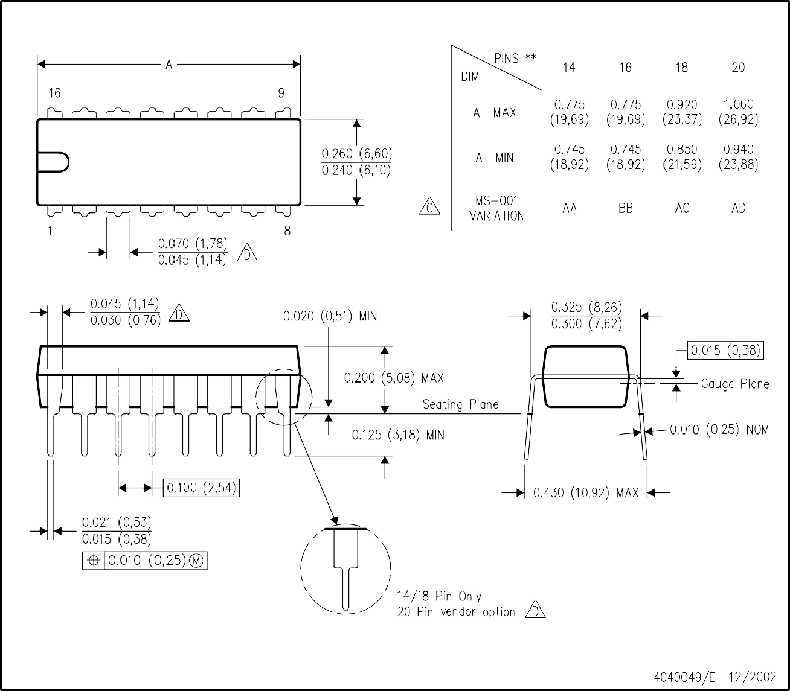







NS0016A

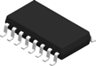
SCALE 1.500

PACKAGE OUTLINE

SOP - 2.00 mm max height
SOP

8.2
TYP
A
1

7.4
1.27
C
SEATING PLANE

PIN 1 ID AREA

14X
16
0.1 C

10.4
10.0
NOTE 3
2X
8.89

8
9
16X 0.51

5.4
B
5.2
NOTE 4
0.35

2.00 MAX
 | 0.25 | C | A | B

0.15 TYP

SEE DETAIL A

0.25
GAGE PLANE

0.3
0.1

0 - 10

1.05
0.55

(1.25)

DETAIL A
TYPICAL

4220735/A 12/2021

NOTES:

- All linear dimensions are in millimeters. Dimensions in parenthesis are for reference only. Dimensioning and tolerancing per ASME Y14.5M.
- This drawing is subject to change without notice.
- This dimension does not include mold flash, protrusions, or gate burrs. Mold flash, protrusions, or gate burrs shall not exceed 0.15 mm, per side.
- This dimension does not include interlead flash. Interlead flash shall not exceed 0.25 mm, per side.

NS0016A

EXAMPLE BOARD LAYOUT

SOP - 2.00 mm max height
SOP

16X (1.85)

SYMM
SEE DETAILS

1 16

16X (0.6)

SYMM

14X (1.27)

8 9

(R0.05) TYP

(7)

LAND PATTERN EXAMPLE
SCALE:7X

SOLDER MASK OPENING
METAL

SOLDER MASK METAL OPENING

0.07 MAX ALL AROUND
0.07 MIN
ALL AROUND

NON SOLDER MASK DEFINED
SOLDER MASK DEFINED

SOLDER MASK DETAILS

4220735/A 12/2021

NOTES: (continued)

- Publication IPC-7351 may have alternate designs.
- Solder mask tolerances between and around signal pads can vary based on board fabrication site.

NS0016A

EXAMPLE STENCIL DESIGN

SOP - 2.00 mm max height
SOP

16X (1.85)

SYMM

1 16

16X (0.6)

SYMM

14X (1.27)

8 9

(R0.05) TYP
(7)

SOLDER PASTE EXAMPLE
BASED ON 0.125 mm THICK STENCIL SCALE:7X

4220735/A 12/2021

NOTES: (continued)

- Laser cutting apertures with trapezoidal walls and rounded corners may offer better paste release. IPC-7525 may have alternate design recommendations.
- Board assembly site may have different recommendations for stencil design.

PW0016A

PACKAGE OUTLINE

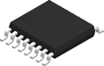
TSSOP - 1.2 mm max height

SCALE 2.500

SMALL OUTLINE PACKAGE

6.6
TYP
A 6.2

SEATING PLANE
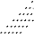C

0.1 C

PIN 1 INDEX AREA

1
14X
16
0.65

5.1
4.9
NOTE 3
2X
4.55

4X (0 -12 )

8

4.5
B
4.3
NOTE 4

9 0.30
0.17
16X
 | 0.1 | C | A | B

1.2 MAX

(0.15) TYP
SEE DETAIL A

0.25
GAGE PLANE

0.15
0.05

0 -8
0.75
0.50

DETA 20 AIL A
TYPICAL

4220204/B 12/2023
NOTES:

- All linear dimensions are in millimeters. Any dimensions in parenthesis are for reference only. Dimensioning and tolerancing per ASME Y14.5M.
- This drawing is subject to change without notice.
- This dimension does not include mold flash, protrusions, or gate burrs. Mold flash, protrusions, or gate burrs shall not exceed 0.15 mm per side.
- This dimension does not include interlead flash. Interlead flash shall not exceed 0.25 mm per side.
- Reference JEDEC registration MO-153.

PW0016A

EXAMPLE BOARD LAYOUT

TSSOP - 1.2 mm max height
SMALL OUTLINE PACKAGE

1
16X (0.45)

16X (1.5)
SYMM

(R0.05) TYP
16

SYMM

14X (0.65)

8 9

(5.8)

LAND PATTERN EXAMPLE
EXPOSED METAL SHOWN SCALE: 10X

SOLDER MASK
OPENING

METAL
METAL UNDER SOLDER MASK
SOLDER MASK OPENING

EXPOSED METAL EXPOSED METAL

0.05 MAX ALL AROUND

0.05 MIN
ALL AROUND

NON-SOLDER MASK DEFINED (PREFERRED)

SOLDE15.000 R MASK DETAILS
SOLDER MASK DEFINED

NOTES: (continued)

- Publication IPC-7351 may have alternate designs.
- Solder mask tolerances between and around signal pads can vary based on board fabrication site.
4220204/B 12/2023

PW0016A

EXAMPLE STENCIL DESIGN

TSSOP - 1.2 mm max height
SMALL OUTLINE PACKAGE

1
16X (0.45)
16X (1.5)
SYMM

(R0.05) TYP
16

SYMM

14X (0.65)

8 9

(5.8)

SOLDER PASTE EXAMPLE
BASED ON 0.125 mm THICK STENCIL SCALE: 10X

4220204/B 12/2023
NOTES: (continued)

- Laser cutting apertures with trapezoidal walls and rounded corners may offer better paste release. IPC-7525 may have alternate design recommendations.
- Board assembly site may have different recommendations for stencil design.

IMPORTANT NOTICE AND DISCLAIMER
TI PROVIDES TECHNICAL AND RELIABILITY DATA (INCLUDING DATASHEETS), DESIGN RESOURCES (INCLUDING REFERENCE DESIGNS), APPLICATION OR OTHER DESIGN ADVICE, WEB TOOLS, SAFETY INFORMATION, AND OTHER RESOURCES “AS IS” AND WITH ALL FAULTS, AND DISCLAIMS ALL WARRANTIES, EXPRESS AND IMPLIED, INCLUDING WITHOUT LIMITATION ANY IMPLIED WARRANTIES OF MERCHANTABILITY, FITNESS FOR A PARTICULAR PURPOSE OR NON-INFRINGEMENT OF THIRD PARTY INTELLECTUAL PROPERTY RIGHTS.
These resources are intended for skilled developers designing with TI products. You are solely responsible for (1) selecting the appropriate TI products for your application, (2) designing, validating and testing your application, and (3) ensuring your application meets applicable standards, and any other safety, security, regulatory or other requirements.
These resources are subject to change without notice. TI grants you permission to use these resources only for development of an application that uses the TI products described in the resource. Other reproduction and display of these resources is prohibited. No license is granted to any other TI intellectual property right or to any third party intellectual property right. TI disclaims responsibility for, and you fully indemnify TI and its representatives against any claims, damages, costs, losses, and liabilities arising out of your use of these resources.
TI’s products are provided subject to TI’s Terms of Sale, TI’s General Quality Guidelines, or other applicable terms available either on ti.com or provided in conjunction with such TI products. TI’s provision of these resources does not expand or otherwise alter TI’s applicable warranties or warranty disclaimers for TI products. Unless TI explicitly designates a product as custom or customer-specified, TI products are standard, catalog, general purpose devices.
TI objects to and rejects any additional or different terms you may propose.

Copyright © 2025, Texas Instruments Incorporated Last updated 10/2025

